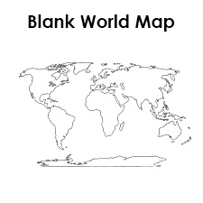
World War I: War or Not?
World War I: War or Not?
As you listen to the background talk, note and write down at least two facts from each slide that are interesting to you. You may write anywhere on this page.

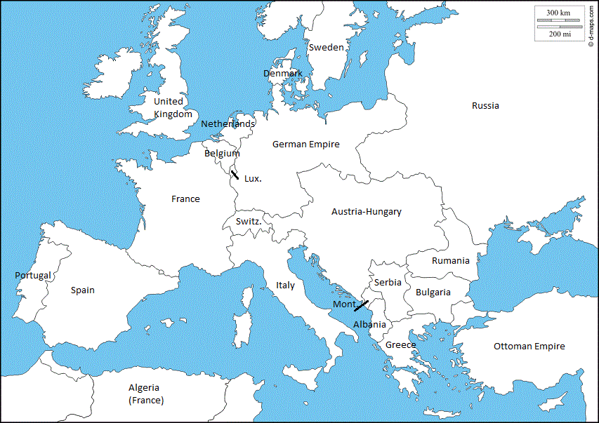
8 United States
9. Mexico

2 Austira-Hungary
5. Germany

1 Serbia
3 Russia
4. France
6. Belgium
7. Britain
Background: Create a Flow Chart showing the Domino Effect following the assassination.

Document A
Lusitania Notice
“Travelers intending to embark on the Lusitania’s Atlantic voyage are reminded that a state of war exists between Germany and her allies and Great Britain and her allies: that a zone of war includes the waters adjacent to the British Isles; that, in accordance with formal notice given by the Imperial German Government, vessels flying the flag of Great Britain or of any of her allies, are liable to destruction in those waters and that travelers sailing in the war zone on ships of Great Britain or her allies do so at their own risk. –German advertisement in the New York Herald, May 1, 1915

Document A—List the evidence that supports “warning”:  1.  2.  3. | Document B (Video)—List the evidence that supports “attack”:  1.  2.  3.
Document C
Zimmerman Note
“..If this attempt is not successful we propose an alliance on the following basis with Mexico: …we shall make war together and together make peace. We shall give general financial support, and it is understood that Mexico is to reconquer the lost territory in New Mexico, Texas, and your settlement.” “…it is certain there will be an outbreak of war with the United States…”
Claim: Mexico should join alliances with Germany. | Reasoning Stems:
Reasoning: Explain how the underlined evidence in the quote proves why Mexico should join alliances with Germany. | This proves…. shows… demonstrates… highlights…  justifies…. explains… illuminates…

Document D
“Unprepared for World War I” Political Cartoon
Evidence from Text:  “What I See" | Claim: (Use at least 2 pieces of evidence)  “What I Think” | Reasoning: (Explain your evidence)  “How I Know”
1.
2.
3.
4.
5.

Document E
Congressional Testimony
You are President Wilson testifying before Congress. You are asking for Congress to declare war on Germany.  Choose the strongest 2 pieces of evidence to persuade Congress to declare war. | You are Senator Norris testifying before Congress. You are asking Congress not to declare war on Germany.  Choose the strongest 2 pieces of evidence to persuade Congress not to declare war.
1.  2. | 1.  2.

Evidence Ranking: 1-6
Choose the bottom 2 pieces of evidence
Choose the top 2 pieces of evidence
Rank the middle.
 | Due to Germany’s determination to win its war on attrition against the Allies, the United States congress should declare war on Germany. |  | With the support of many Americans who are not in favor of the United States entering the war and considering it a European affair, President Woodrow Wilson initially pledges neutrality for the United States which should be maintained throughout the war.
 | “Germany and its Allies are the aggressive nations in this war…August 1914 Germany invaded Belgium (neutral)…executed thousands of innocent civilians  ( 1 Declare War on Germany Article) |  | - Uncle Sam sleepy and disheveled, We had not been at war since the 1860s  - Army and Navy boots are too small  - Bank Book , money for war?  - Footboard of bed—Peace  (Doc. D)
 | “On February 1, 1917 its (Germany’s) government announced that it would resume unrestricted submarine warfare… This violates all rules of warfare.”  ( 5 Declare War on Germany Article) |  | “….men dying for no purpose…if we get involved, we should expect at least 100,000 and maybe 200,000 Americans to die.”  ( 2 Stay Neutral During this War)
 | “…we make Mexico a proposal of alliance on the following basis: generous financial support and an understanding on our (Germany’s) part that Mexico is to reconquer lost territory in Texas, New Mexico, and Arizona.”  (Doc. C) |  | “…Many instances of cruelty and inhumanity can be found on both sides. Men are often biased in their judgement on account of their sympathy and interests. To my mind, what we ought to have obeyed from the beginning was strictest neutrality.”  (Doc. E)
 | “...it is a war against all nations. American ships have been sunk, American lives taken, in ways it has stirred us very deeply to learn of, but the ships and people of other neutral and friendly nations have been sunk and overwhelmed in the waters in the same way. There has been no discrimination. The challenge is to all mankind.”  (Doc E) |  | “Travelers intending to embark on the Atlantic Voyage are minded that a state of war exists between Germany and her allies and Great Britain and her allies;…vessels flying the flag of Great Britain, or any of her allies, are liable to destruction in those waters….travelers sailing in war zone..do so at their own risk.”  (Doc A)
 | “..armed neutrality, it now appears, is impracticable….German Government denies the right of neutrals to use arms…even in the defense of rights.”  (Doc E) |  | “There is evidence that guns and ammunition were being smuggled to Britain on the Lusitania when a German U-Boat sank it.”  ( 5 Stay Neutral During this War)
 | “…we shall fight for the things which we have always carried nearest our hearts—for democracy, for the right of those who submit to authority to have a voice in their own governments, for the rights and liberties of small nations…as shall bring peace and safety to all nations and make the world itself at least free”  ( E) |  | “It is now demanded that the American citizens shall be used as insurance policies to guarantee the safe delivery of munitions manufacturers, stockbrokers, and bond dealers must be still further increased by our entrance into the war.  (Doc. E)
“They Say, I Say” Argument—World War I: War or Not?
Word Bank
(Use 4 words, in claims or reasoning)

Neutrality Alliance Nationalism Militarism Imperialism
U-Boats Negotiate blockade civilians Submarine Warfare
Lusitania Unrestricted allegiance disregard Zimmerman Note

On June 28, 1914, a Serbian nationalist assassinated the nephew of Austria-Hungary’s emperor. One month later, Austria-Hungary declared war on Serbia. Russia and France then mobilized their armies to assist Serbia. Germany, Austria-Hungary’s ally, then invaded Belgium in order to bypass several French forts. Britain, Belgium’s ally, then declared war on Germany. The Germans tried to blockade ports using submarines, called U-boats. The U-boats often sunk ships without warning. For a brief span, Germany agreed to warn American merchant ships. However, on February 1, 1917, Germany announced that it would end this policy.
Write an argumentative piece with a counterclaim that answers the question:
Should the United States government declare War or Not?

The general argument made by author X in document/text/video, ________, is that_________________ (citation). More specifically, X argues that _____________ (citation). She/he write, “ ___________________. (citation)” In this passage, X is suggesting that _____________. In conclusion, X’s belief is that _______________.

This argument is wrong, because ___________. More specifically, it can be asserted that _________. For example, __________ (citation). Additionally, the evidence of _________ (citation) points to _________. Although X might object that _______ (citation), I maintain that __________. Therefore, I conclude that __________.

“They Say, I Say” Argument—World War I War or Not”
Word Bank
(Use 4 words, in claims or reasoning)

Neutrality Alliance Nationalism Militarism Imperialism
U-Boats Negotiate blockade civilians Submarine Warfare
Lusitania Unrestricted allegiance disregard Zimmerman Note
On June 28, 1914, a Serbian nationalist assassinated the nephew of Austria-Hungary’s emperor. One month later, Austria-Hungary declared war on Serbia. Russia and France then mobilized their armies to assist Serbia. Germany, Austria-Hungary’s ally, then invaded Belgium in order to bypass several French forts. Britain, Belgium’s ally, then declared war on Germany. The Germans tried to blockade ports using submarines, called U-boats. The U-boats often sunk ships without warning. For a brief span, Germany agreed to warn American merchant ships. However, on February 1, 1917, Germany announced that it would end this policy.
Write an argumentative piece with a counterclaim that answers the question:
Should the United States government declare War or Not?
________________________________________________________________________________________________________________________________________________________________________________________________________________________________________________________________________________________________________________________________________________________________________________________________________________________________________________________________________________________________________________________________________________________________________________________________________________________________________________________________________________________________________________________________________________________________________________________________________________________________________________________________________________________________________________________________________________________________________________________________________________________________________________________________________________________________________________________________________________________________________________________________________________________________________________________________________________________________________________________________________________________________________________________________________________________________________________________________________________________________
________________________________________________________________________________________________________________________________________________________________________________________________________________________________________________________________________________________________________________________________________________________________________

