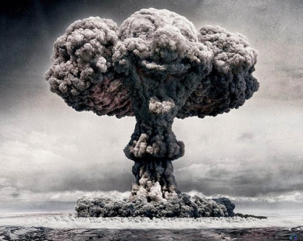
Atomic Decisions
1 = Strongly Disagree 10 = Strongly Agree

- The atomic bomb should have been built.
1 2 3 4 5 6 7 8 9 10

- The 1st atomic bomb should have been dropped on Hiroshima.
1 2 3 4 5 6 7 8 9 10

- The 2nd atomic bomb should have been dropped on Nagasaki.
1 2 3 4 5 6 7 8 9 10

